**VECTR v6.0.0 Feature Breakdown**

Table of Contents

Enhanced Security Configuration Options 2

Improved Support for File Import 4

# Enhanced Security Configuration Options

What is it?

VECTR now support enhanced security configuration features, including MFA with TOTP support and enrollment with popular apps such as Microsoft Authenticator, minimum requirements for a password, and account lockout.

How does it work?

Administrators can access the configuration screen through the Administration -> Security Configuration Screen.

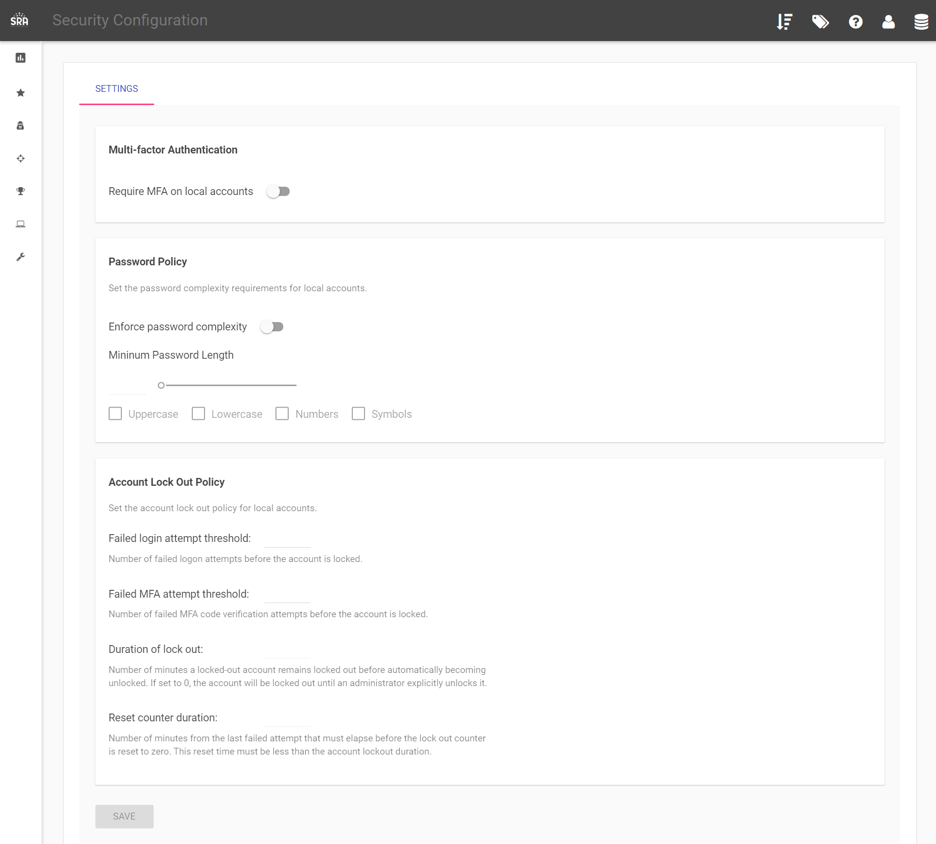

MFA can also be enabled for individual users from the user profile menu.

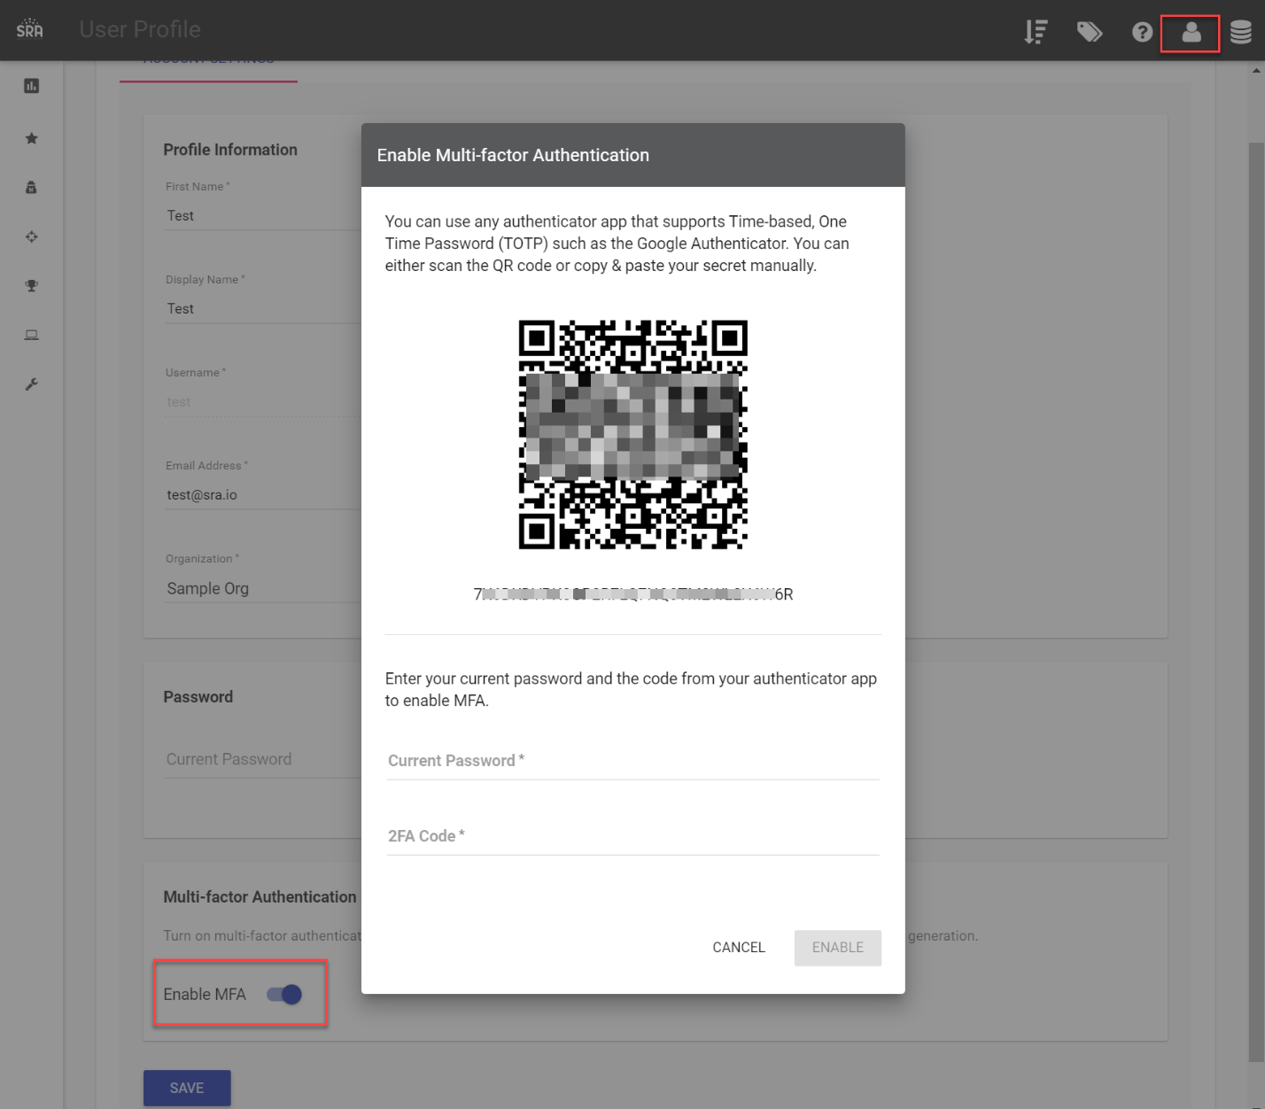

How can this feature help me?

This will allow Administrators to enforce MFA, password complexity and account lockout for VECTR users.

# Improved Support for File Import

What is it?

Merged all supported filetypes into a single panel under Administration -> Import Data -> File Import

How does it work?

You can use the import widget to import data from various sources.

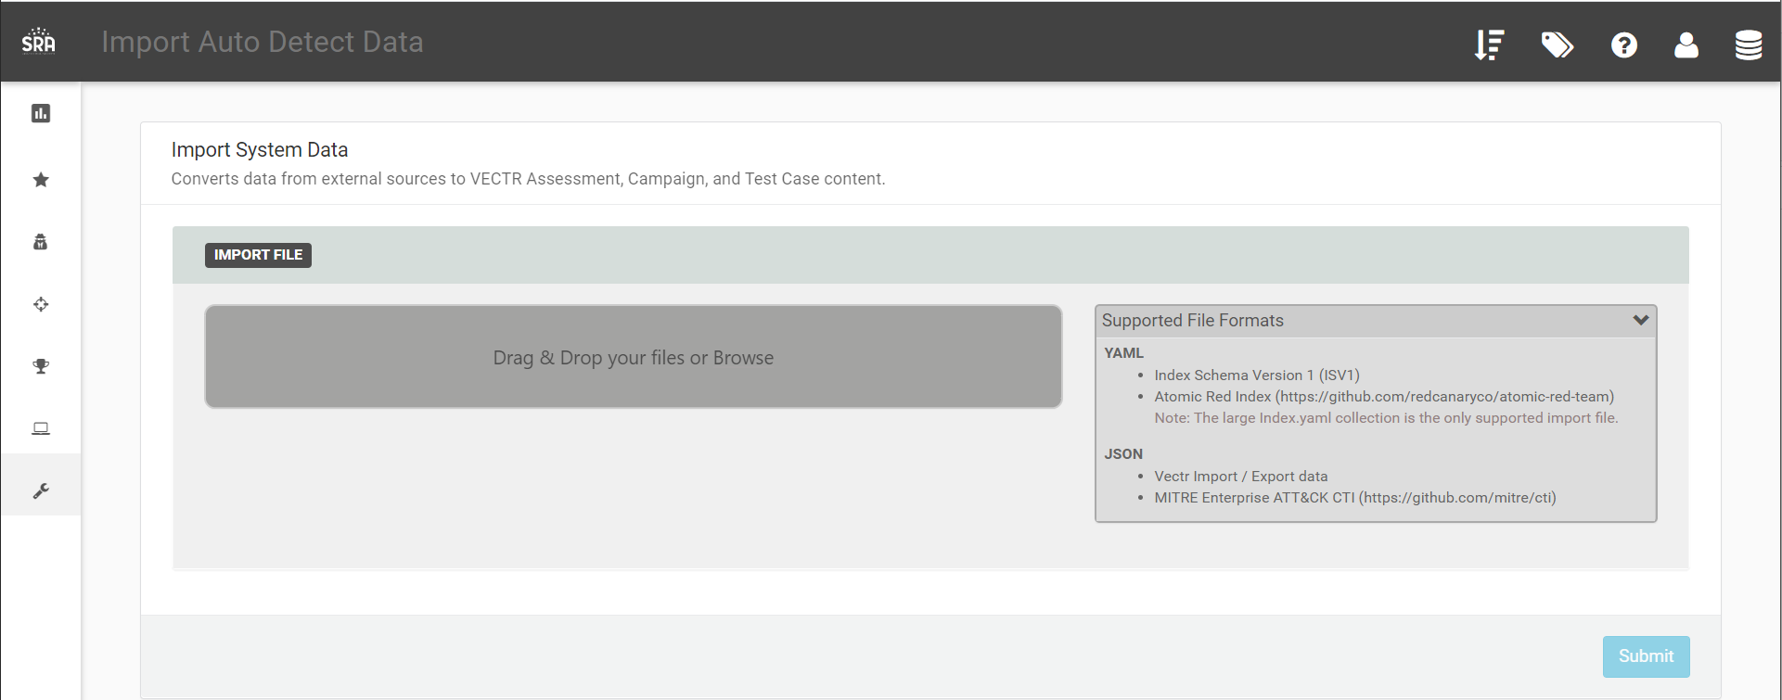

How can this feature help me?

Imported data will create Administration templates that can be used in future Assessments. This screen provides additional information on what file types are currently supported for imports and feedback to the user on content types successfully identified and parsed.